**COMPUTER GRAPHICS LAB FILE**

**Subject Code: COE-308**

|  |
| --- |
| **Submitted by:**  **Manish kumar gupta**  **260/co/08**  **Coe-1** |

Contents

LINE DDA ALGORITHM 3

LINE MID - POINT ALGORITHM 4

LINE BRESENHAM ALGORITHM 5

CIRCLE MID - POINT ALGORITHM 6

ELLIPSE MID - POINT ALGORITHM 7

HYPERBOLA MID - POINT ALGORITHM 8

CIRCLE BRESENHAM ALGORITHM 9

ELLIPSE BRESENHAM ALGORITHM 10

HYPERBOLA BRESENHAM ALGORITHM 11

BOUNDARY FILL ALGORITHM 12

FLOOD FILL ALGORITHM 13

CIRCLE USING FIRST ORDER DIFFERENTIAL APPROACH 14

CIRCLE USING SECOND ORDER DIFFERENTIAL APPROACH 15

SCAN LINE ALGORITHM 16

# LINE DDA ALGORITHM

#include<stdio.h>

#include<conio.h>

#include<math.h>

#include<graphics.h>

#define R(a) (a+0.5)

int set(float x,float y)

{ x=x+319; y=239-y;

x=R(x); y=R(y);

putpixel((int)x,(int)y,15);

return 0;

}

int algo(float x1,float y1,float x2,float y2)//DDA

{ float x,y,dx,dy,step,xinc,yinc;

dx=x2-x1; dy=y2-y1;

step=(abs((int)dx)>abs((int)dy)) ? dx : dy;

step=abs((int)step);

if(!dx&&!dy)

{ set(x1,y1); return 0;

}

xinc=dx/step; yinc=dy/step;

x=x1; y=y1;

while(x!=x2&&y!=y2)

{ set(x,y);

x+=xinc; y+=yinc;

}

return 0;

}

int main()

{ int gdrv=DETECT,gmd;

float x1,x2,y1,y2;

printf("Enter coordinates(x1,y1): ");

scanf("%f%f",&x1,&y1);

printf("Enter coordinates(x2,y2): ");

scanf("%f%f",&x2,&y2);

initgraph(&gdrv,&gmd,"");

graphdefaults();

rectangle(0,0,639,479);

line(319,0,319,479);

line(0,239,639,239);

algo(x1,y1,x2,y2);

getch();

closegraph();

return 0;

}

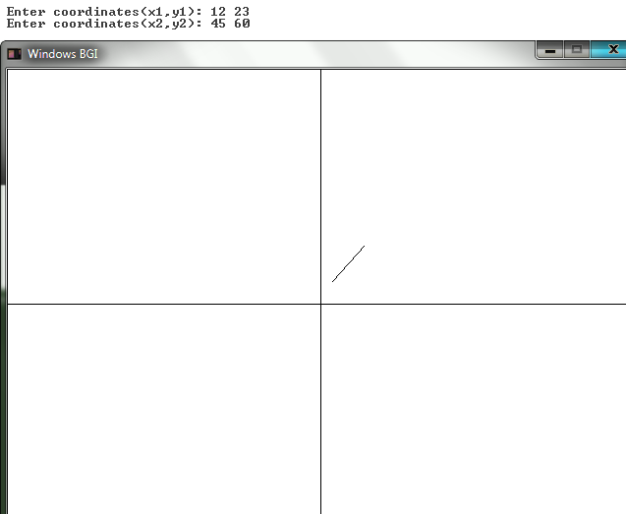

# LINE MID - POINT ALGORITHM

#include<stdio.h>

#include<conio.h>

#include<math.h>

#include<graphics.h>

#define R(a) (a+0.5)

int set(float x,float y)

{ x=x+319; y=239-y;

x=R(x); y=R(y);

putpixel((int)x,(int)y,15);

return 0;

}

int algo(float x1,float y1,float x2,float y2)//MID-POINT

{ float inc,m,dx,dy,x,y,d,step,xinc,yinc;

dx=x2-x1; dy=y2-y1;

m=(abs((int)dx)>abs((int)dy)) ? dy/dx : dx/dy;

step=(abs((int)dx)>abs((int)dy)) ? dx : dy;

step=abs((int)step);

if(!dx&&!dy)

{ set(x1,y1); return 0;

}

xinc=dx/step; yinc=dy/step;

x=x1; y=y1;

if(abs((int)dx)>abs((int)dy))

{while(x!=x2&&y!=y2)

{ set(x,y);

x+=xinc;

d=y1+m*(x-x1);

if((y+0.5)>d) y=d;

else y+=yinc;

}

}

else

{while(x!=x2&&y!=y2)

{ set(x,y);

y+=yinc;

d=x1+m*(y-y1);

if((x+0.5)>d) x=d;

else x+=xinc;

}

}

return 0;

}

int main()

{ int gdrv=DETECT,gmd;

float x1,x2,y1,y2;

printf("Enter coordinates(x1,y1): ");

scanf("%f%f",&x1,&y1);

printf("Enter coordinates(x2,y2): ");

scanf("%f%f",&x2,&y2);

initgraph(&gdrv,&gmd,"");

graphdefaults();

rectangle(0,0,639,479);

line(319,0,319,479);

line(0,239,639,239);

algo(x1,y1,x2,y2);

getch();

closegraph();

return 0;

}

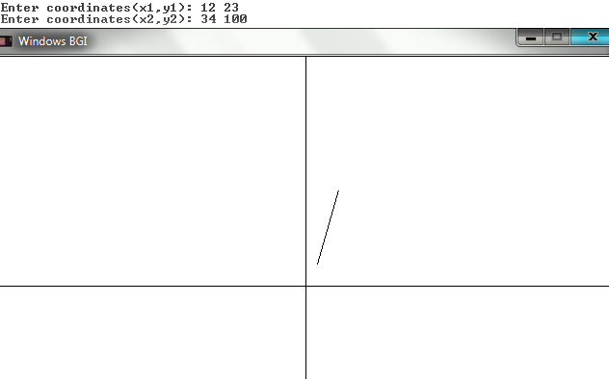

# LINE BRESENHAM ALGORITHM

#include<stdio.h>

#include<conio.h>

#include<math.h>

#include<graphics.h>

#define R(a) (a+0.5)

int set(float x,float y)

{ x=x+319; y=239-y;

x=R(x); y=R(y);

putpixel((int)x,(int)y,15);

return 0;

}

int algo(float x1,float y1,float x2,float y2)//BRESENHAM

{ float p,dx,dy,x,y,step,xinc,yinc;

dx=x2-x1; dy=y2-y1;

p=(abs((int)dx)>abs((int)dy)) ? dx-2*dy : dy-2*dx;

step=(abs((int)dx)>abs((int)dy)) ? dx : dy;

step=abs((int)step);

if(!dx&&!dy)

{ set(x1,y1); return 0;

}

xinc=dx/step; yinc=dy/step;

x=x1; y=y1;

if(abs((int)dx)>abs((int)dy))

{while(x!=x2&&y!=y2)

{ set(x,y);

if(p>0)

{ y=y; p=p-2*dy; }

else

{ y+=yinc; p=p-2*dy+2*dx; }

x+=xinc;

}

}

else

{while(x!=x2&&y!=y2)

{ set(x,y);

if(p>0)

{ x=x; p=p-2*dx; }

else

{ x+=xinc; p=p-2*dx+2*dy; }

y+=yinc;

}

}

return 0;

}

int main()

{ int gdrv=DETECT,gmd;

float x1,x2,y1,y2;

printf("\n Enter coordinates(x1,y1): ");

scanf("%f%f",&x1,&y1);

printf(" Enter coordinates(x2,y2): ");

scanf("%f%f",&x2,&y2);

initgraph(&gdrv,&gmd,"");

graphdefaults();

rectangle(0,0,639,479);

line(319,0,319,479);

line(0,239,639,239);

algo3(x1,y1,x2,y2);

getch();

closegraph();

return 0;

}

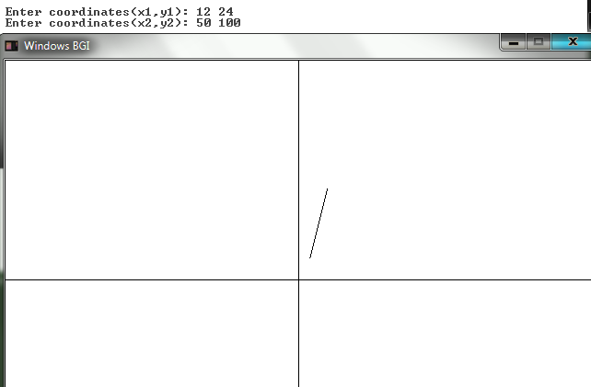

# CIRCLE MID - POINT ALGORITHM

#include<stdio.h>

#include<conio.h>

#include<math.h>

#include<graphics.h>

#define R(a) (a+0.5)

int set(float x,float y)

{ x=x+319; y=239-y;

x=R(x); y=R(y);

putpixel((int)x,(int)y,15);

return 0;

}

int algo(float x1,float y1,float r1)//midpoint circle

{ float p,x,y;

p=3/4-2*r1;

x=r1; y=0;

while(x>=y)

{ set(x1+x,y1+y);set(x1-x,y1+y);

set(x1+x,y1-y);set(x1-x,y1-y);

set(x1+y,y1+x);set(x1-y,y1+x);

set(x1+y,y1-x);set(x1-y,y1-x);

if(p<0)

{ x=x; p=p+2*y+3; }

else

{ x--; p=p-2*(x-y)+3; }

y++;

}

}

int main()

{ int gdrv=DETECT,gmd;

initgraph(&gdrv,&gmd,"");

graphdefaults();

rectangle(0,0,639,479);

line(319,0,319,479);

line(0,239,639,239);

algo(70,50,100);

getch();

closegraph();

return 0;

}

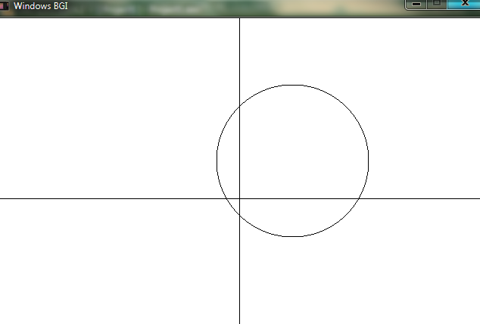

# ELLIPSE MID - POINT ALGORITHM

#include<stdio.h>

#include<conio.h>

#include<math.h>

#include<graphics.h>

#define R(a) (a+0.5)

int set(float x,float y)

{ x=x+319; y=239-y;

x=R(x); y=R(y);

putpixel((int)x,(int)y,15);

return 0;

}

int algo(float x1,float y1,float a,float b)//MID POINT ellipse

{ float p,x,y,sa,sb;

sa=a*a; sb=b*b;

p=sa+sb/4-sb*a;

x=a; y=0;

while(sb*x>=sa*y)

{ set(x1+x,y1+y);set(x1-x,y1+y);set(x1+x,y1-y);set(x1-x,y1-y);

if(p>0)

{ x--; p=p-2*sb*x+sa*(3+2*y); }

else

{ x=x; p=p+sa*(3+2*y); }

y++;

}

p=sa/4+sb-sa*sb+sb*x*(x-2)+sa*y*(y+1);

while(x>=0)

{ set(x1+x,y1+y);set(x1-x,y1+y);set(x1+x,y1-y);set(x1-x,y1-y);

if(p>0)

{ y=y; p=p-sb*(2*x+1); }

else

{ y++; p=p+2*sa*(1+y)-sb*(2*x+1); }

x--;

}

}

int main()

{ int gdrv=DETECT,gmd;

float x,y,r1,r2;

initgraph(&gdrv,&gmd,"");

graphdefaults();

rectangle(0,0,639,479);

line(319,0,319,479);

line(0,239,639,239);

printf("\n Enter (x,y,a,b): ");

scanf("%f%f%f%f",&x,&y,&r1,&r2);

algo(x,y,r1,r2);

getch();

closegraph();

return 0;

}

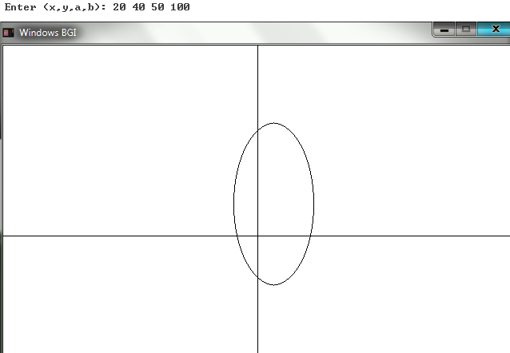

# HYPERBOLA MID - POINT ALGORITHM

#include<stdio.h>

#include<conio.h>

#include<math.h>

#include<graphics.h>

#define R(a) (a+0.5)

int set(float x,float y)

{ x=x+319; y=239-y;

x=R(x); y=R(y);

putpixel((int)x,(int)y,15);

return 0;

}

int algo(float x1,float y1,float a,float b)//MID POINT hyperbola

{ float p,x,y,sa,sb;

sa=a*a; sb=b*b;

p=-sa+sb/4-sb*a;

x=a; y=0;

while(x<=5*a)

{ set(x1+x,y1+y);set(x1-x,y1+y);set(x1+x,y1-y);set(x1-x,y1-y);

if(p<0)

{ x++; p=p+2*sb*(x+1)-sa*(3+2*y); }

else

{ x=x; p=p-sa*(3+2*y); }

y++;

}

}

int main()

{ int gdrv=DETECT,gmd;

float x,y,r1,r2;

initgraph(&gdrv,&gmd,"");

graphdefaults();

rectangle(0,0,639,479);

line(319,0,319,479);

line(0,239,639,239);

printf("\n Enter (x,y,a,b): ");

scanf("%f%f%f%f",&x,&y,&r1,&r2);

algo(x,y,r1,r2);

getch();

closegraph();

return 0;

}

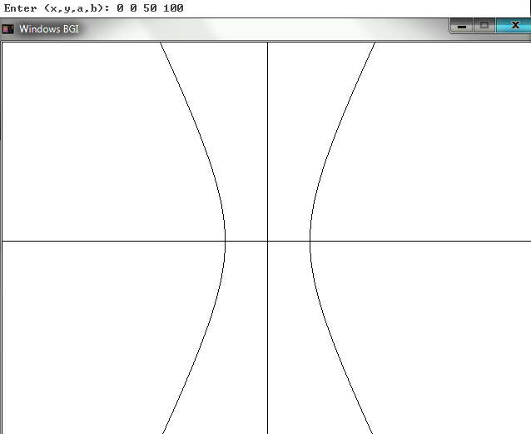

# CIRCLE BRESENHAM ALGORITHM

#include<stdio.h>

#include<conio.h>

#include<math.h>

#include<graphics.h>

#define R(a) (a+0.5)

int set(float x,float y)

{ x=x+319; y=239-y;

x=R(x); y=R(y);

putpixel((int)x,(int)y,15);

return 0;

}

int algo(float x1,float y1,float r1)//BRESENHAM circle

{ float p,x,y;

p=3-2*r1;

y=r1; x=0;

while(y>=x)

{ set(x1+x,y1+y);set(x1-x,y1+y);set(x1+x,y1-y);set(x1-x,y1-y);

set(x1+y,y1+x);set(x1-y,y1+x);set(x1+y,y1-x);set(x1-y,y1-x);

if(p>0)

{ y--; p=p+2*(3+2*x)+4*(1-y); }

else

{ y=y; p=p+2*(3+2*x); }

x++;

}

}

int main()

{ int gdrv=DETECT,gmd;

float x,y,r1,r2;

initgraph(&gdrv,&gmd,"");

graphdefaults();

rectangle(0,0,639,479);

line(319,0,319,479);

line(0,239,639,239);

printf("\n Enter (x,y,a): ");

scanf("%f%f%f",&x,&y,&r1);

algo(x,y,r1);

getch();

closegraph();

return 0;

}

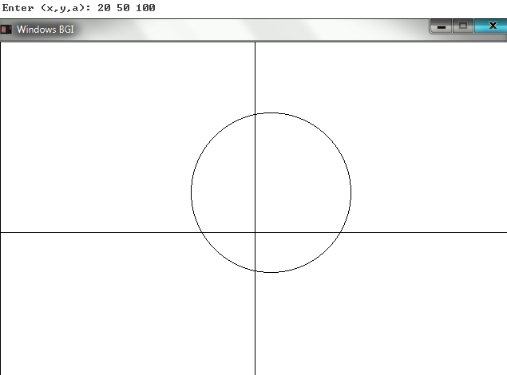

# ELLIPSE BRESENHAM ALGORITHM

#include<stdio.h>

#include<conio.h>

#include<math.h>

#include<graphics.h>

#define R(a) (a+0.5)

int set(float x,float y)

{ x=x+319; y=239-y;

x=R(x); y=R(y);

putpixel((int)x,(int)y,15);

return 0;

}

int algo(float x1,float y1,float a,float b)//BRESENHAM ellipse

{ float p,x,y,sa,sb;

sa=a*a; sb=b*b;

p=2*sb-sa-2*sa*b;

x=0; y=b;

while(sb*x<=sa*y)

{ set(x1+x,y1+y);set(x1-x,y1+y);set(x1+x,y1-y);set(x1-x,y1-y);

if(p>0)

{ y--; p=p+4*sa*(1-y)+sb*2*(3+2*x); }

else

{ y=y; p=p+2*sb*(3+2*x); }

x++;

}

p=sb*(2*x*(x+1)+1)+2*sa*(1+y*(y-2))-2*sa*sb;

while(y>=0)

{ set(x1+x,y1+y);set(x1-x,y1+y);set(x1+x,y1-y);set(x1-x,y1-y);

if(p>0)

{ x=x; p=p-2*sa*(2*y+1); }

else

{ x++; p=p-2*sa*(2*y+1)+sb*4*(x+1); }

y--;

}

}

int main()

{ int gdrv=DETECT,gmd;

float x,y,r1,r2;

initgraph(&gdrv,&gmd,"");

graphdefaults();

rectangle(0,0,639,479);

line(319,0,319,479);

line(0,239,639,239);

printf("\n Enter (x,y,a,b): ");

scanf("%f%f%f%f",&x,&y,&r1,&r2);

algo(x,y,r1,r2);

getch();

closegraph();

return 0;

}

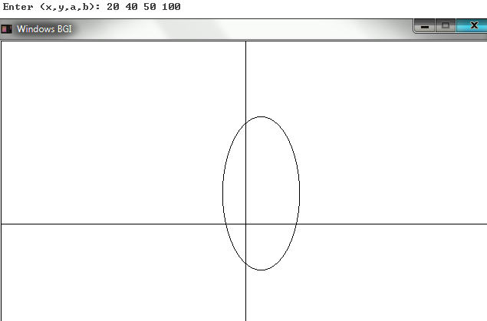

# HYPERBOLA BRESENHAM ALGORITHM

#include<stdio.h>

#include<conio.h>

#include<math.h>

#include<graphics.h>

#define R(a) (a+0.5)

int set(float x,float y)

{ x=x+319; y=239-y;

x=R(x); y=R(y);

putpixel((int)x,(int)y,15);

return 0;

}

int algo(float x1,float y1,float a,float b)//BRESENHAM hyperbola

{ float p,x,y,sa,sb;

sa=a*a; sb=b*b;

p=-2*sa+sb+2*sb*a;

x=a; y=0;

while(x<=5*a)

{ set(x1+x,y1+y);set(x1-x,y1+y);set(x1+x,y1-y);set(x1-x,y1-y);

if(p<0)

{ x++; p=p+4*sb*(x+1)-2*sa*(3+2*y); }

else

{ x=x; p=p-2*sa*(3+2*y); }

y++;

}

}

int main()

{ int gdrv=DETECT,gmd;

float x,y,r1,r2;

initgraph(&gdrv,&gmd,"");

graphdefaults();

rectangle(0,0,639,479);

line(319,0,319,479);

line(0,239,639,239);

printf("\n Enter (x,y,a,b): ");

scanf("%f%f%f%f",&x,&y,&r1,&r2);

algo(x,y,r1,r2);

getch();

closegraph();

return 0;

}

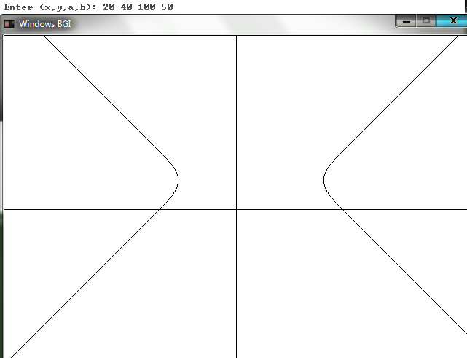

# BOUNDARY FILL ALGORITHM

#include<stdio.h>

#include<conio.h>

#include<math.h>

#include<graphics.h>

#define R(a) (a+0.5)

int set(float x,float y,int c)

{ x=x+319; y=239-y;

x=R(x); y=R(y);

putpixel((int)x,(int)y,c);

return 0;

}

int bfill(float x,float y,int bc,int fc)

{ int c=(int)getpixel(319+(int)x,239-(int)y);

if(c!=bc&&c!=fc)

{ set(x,y,fc);

bfill(x+1,y,bc,fc);

bfill(x-1,y,bc,fc);

bfill(x,y+1,bc,fc);

bfill(x,y-1,bc,fc);

}

return 0;

}

int main()

{ int gdrv=DETECT,gmd;

initgraph(&gdrv,&gmd,"");

graphdefaults();

rectangle(0,0,639,479);

line(319,0,319,479);

line(0,239,639,239);

rectangle(319-20,239-30,319-120,239-110);

line(319+0,239-0,319-150,239-150);

bfill(-110,100,15,10);

ffill(100,100,0,15);

getch();

closegraph();

return 0;

}

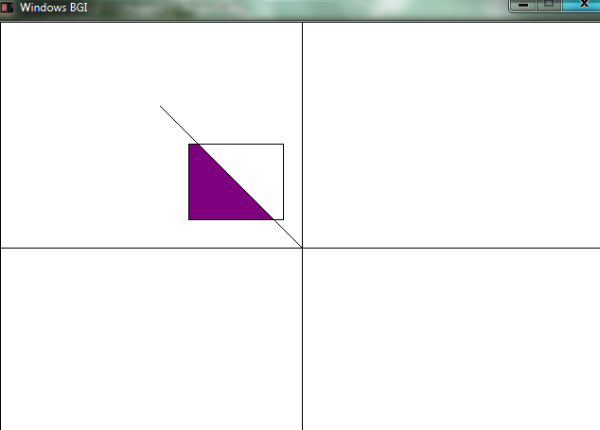

# FLOOD FILL ALGORITHM

#include<stdio.h>

#include<conio.h>

#include<math.h>

#include<graphics.h>

#define R(a) (a+0.5)

int set(float x,float y,int c)

{ x=x+319; y=239-y;

x=R(x); y=R(y);

putpixel((int)x,(int)y,c);

return 0;

}

int ffill(float x,float y,int pc,int fc)

{ int c=(int)getpixel(319+(int)x,239-(int)y);

if(c==pc)

{ set(x,y,fc);

ffill(x+1,y,pc,fc);

ffill(x-1,y,pc,fc);

ffill(x,y+1,pc,fc);

ffill(x,y-1,pc,fc);

}

return 0;

}

int main()

{ int gdrv=DETECT,gmd;

initgraph(&gdrv,&gmd,"");

graphdefaults();

rectangle(0,0,639,479);

line(319,0,319,479);

line(0,239,639,239);

setcolor(4);

line(319+20,239-30,319+120,239-30);

setcolor(6);

line(319+120,239-30,319+120,239-110);

setcolor(11);

line(319+20,239-30,319+20,239-110);

setcolor(9);

line(319+20,239-110,319+120,239-110);

ffill(100,100,0,15);

getch();

closegraph();

return 0;

}

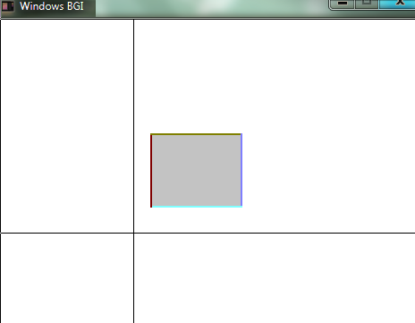

# CIRCLE USING FIRST ORDER DIFFERENTIAL APPROACH

#include<stdio.h>

#include<conio.h>

#include<math.h>

#include<graphics.h>

#define R(a) (a+0.5)

int set(float x,float y)

{ x=x+319; y=239-y;

x=R(x); y=R(y);

putpixel((int)x,(int)y,15);

return 0;

}

int algo10(float x1,float y1,float r1)//first difference circle

{ float p,x,y;

p=3/4-2*r1;

x=r1; y=0;

while(x>=y)

{ set(x1+x,y1+y);set(x1-x,y1+y);

set(x1+x,y1-y);set(x1-x,y1-y);

set(x1+y,y1+x);set(x1-y,y1+x);

set(x1+y,y1-x);set(x1-y,y1-x);

if(p<0)

{ x=x; p=p+2*y+3; }

else

{ x--; p=p-2*(x-y)+3; }

y++;

}

}

int main()

{ int gdrv=DETECT,gmd;

initgraph(&gdrv,&gmd,"");

graphdefaults();

rectangle(0,0,639,479);

line(319,0,319,479);

line(0,239,639,239);

algo10(70,50,100);

getch();

closegraph();

return 0;

}



# CIRCLE USING SECOND ORDER DIFFERENTIAL APPROACH

#include<stdio.h>

#include<conio.h>

#include<math.h>

#include<graphics.h>

#define R(a) (a+0.5)

int set(float x,float y)

{ x=x+319; y=239-y;

x=R(x); y=R(y);

putpixel((int)x,(int)y,15);

return 0;

}

int algo(float x1,float y1,float r1)//second difference circle

{ float d,e,se,x,y;

d=3/4-2*r1;

e=3; se=3-2*r1;

x=r1; y=0;

while(x>=y)

{ set(x1+x,y1+y);set(x1-x,y1+y);

set(x1+x,y1-y);set(x1-x,y1-y);

set(x1+y,y1+x);set(x1-y,y1+x);

set(x1+y,y1-x);set(x1-y,y1-x);

if(d<0)

{ x=x; d+=e;e+=2;se+=2; }

else

{ x--; d+=se;e+=2;se+=4; }

y++;

}

}

int main()

{ int gdrv=DETECT,gmd;

initgraph(&gdrv,&gmd,"");

graphdefaults();

rectangle(0,0,639,479);

line(319,0,319,479);

line(0,239,639,239);

algo(-50,50,50);

getch();

closegraph();

return 0;

}

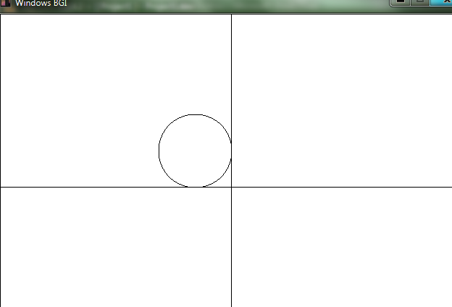

# SCAN LINE ALGORITHM

#include<stdio.h>

#include<conio.h>

#include<math.h>

#include<graphics.h>

#define R(a) (a+0.5)

#define N 6

int set(float x,float y,int c)

{ x=x+319; y=239-y;

x=R(x); y=R(y);

putpixel((int)x,(int)y,c);

return 0;

}

int algo()

{ float dx,dy,x,y,max,min;

float pt[N+1][2]={ {50, 20},{20, 40},{35, 60},{50, 40},{65,60},{80,40},{50, 20} };

float edge[N][2],m[N]={0},ar[N]={0};//x,y ymin,ymax

int i,j,count;

for(i=0;i<N;i++)//edge ymin,ymax

{ if((int)pt[i][1]>(int)pt[i+1][1])

{ edge[i][0]=pt[i+1][1];

edge[i][1]=pt[i][1];

}

else

{ edge[i][0]=pt[i][1];

edge[i][1]=pt[i+1][1];

}

}

for(i=0;i<N;i++)//edge m

{ dx=(pt[i][0]-pt[i+1][0]);

dy=(pt[i][1]-pt[i+1][1]);

if(!dy&&!dx) m[i]=0;

else m[i]=dx/dy;

}

min=240;//start y

max=-240;//end y

for(i=0;i<N;i++)

{ if((int)min>(int)edge[i][0])

min=edge[i][0];

if((int)max<(int)edge[i][1])

max=edge[i][1];

}

for(y=min+1;y<max;y++)

{

for(i=0,count=0;i<N;i++)//intersect x

{ if((int)y>=(int)edge[i][0]&&(int)y<=(int)edge[i][1])

{ ar[count]=pt[i][0]+m[i]*(y-pt[i][1]);

if(ar[count]==ar[count-1])

{ if((edge[i][0]==edge[i-1][1])&&(edge[i][1]>edge[i-1][1]))

count--;

if((edge[i-1][0]==edge[i][1])&&(edge[i][0]<edge[i-1][1]))

count--;

}

count++;

}

}

for(i=0;i<count;i+=2)

{ for(x=ar[i];x<ar[i+1];x++)

set(x,y,10);

}

}

for(i=0;i<N;i++)

line(319+(int)pt[i][0],239-(int)pt[i][1],319+(int)pt[i+1][0],239-(int)pt[i+1][1]);

return 0;

}

int main()

{ int gdrv=DETECT,gmd,n;

initgraph(&gdrv,&gmd,"");

graphdefaults();

rectangle(0,0,639,479);

line(319,0,319,479);

line(0,239,639,239);

algo();

getch();

closegraph();

return 0;

}

